# CODEX core use cases

This document contains the “key path” scenarios. The intent is to describe the primary user-flow through the application so that completeness can be tested before launch.

## CODEX “stability release” (1) key path scenario

The user goes to codex.jpl.nasa.gov and sees the CODEX user-interface. User Imports a file and decides to load the Chemcam demo data to explore.

The user starts by selecting a few pairs of data to draw as Scatterplots and Heat Maps: Ti vs. [Al, Fe, Mg]. User will explore a few outlier data points to compare across the various Scatterplots by circling them and seeing where the groups lie across other graphs.

Then user will activate all four (or more) chemical species and perform Clustering. On the Cluster preview page, user will choose help for one or more of the algorithms. User will choose one of the clustering algorithms and select execution parameters and outputs.

After Clustering completes, the user will re-color some of the Scatterplots using the new clusters that were created.

### Key path scenario

1. Open the URL

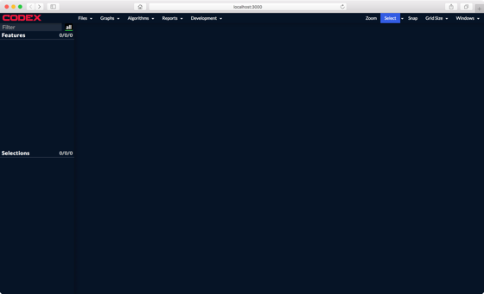

2. Open ChemCam example data

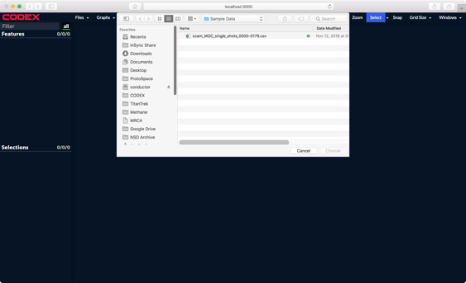

3. Make some scatter plots

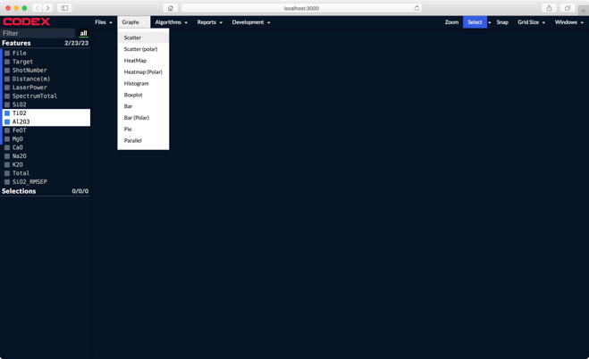 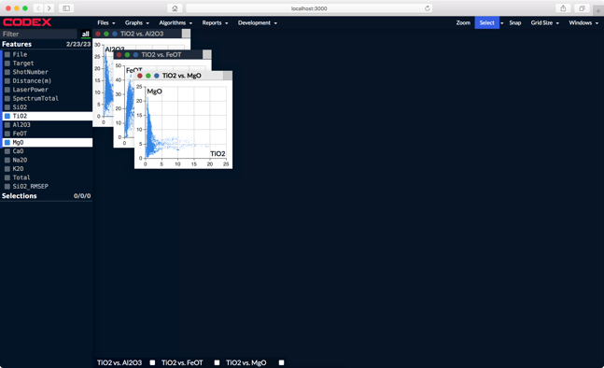

4. Circle an interesting outlier and see how it falls across each scatter.

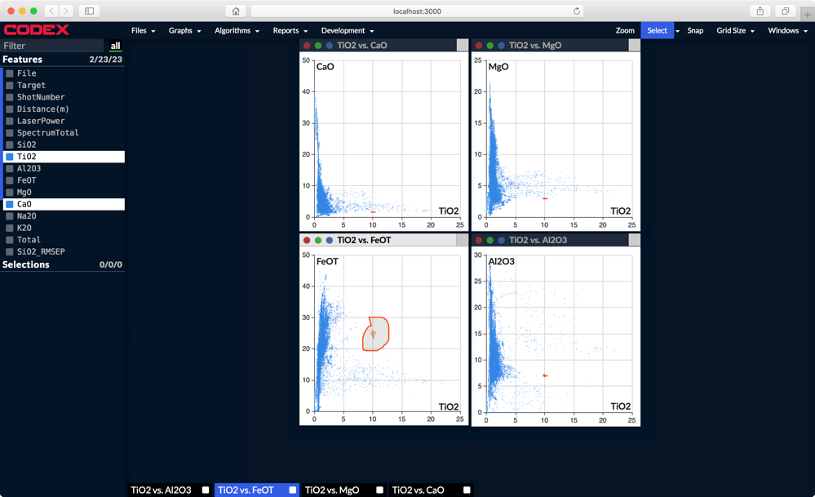

5. Run clustering on all four (or more) Features

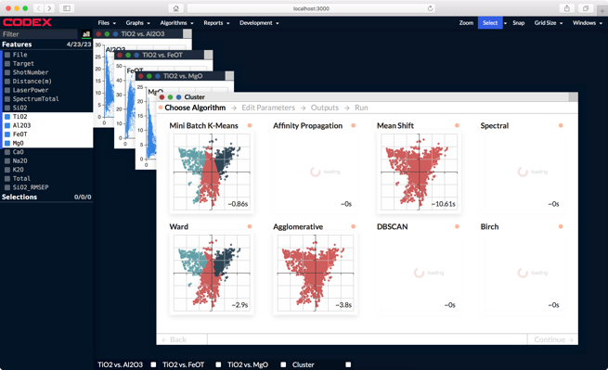 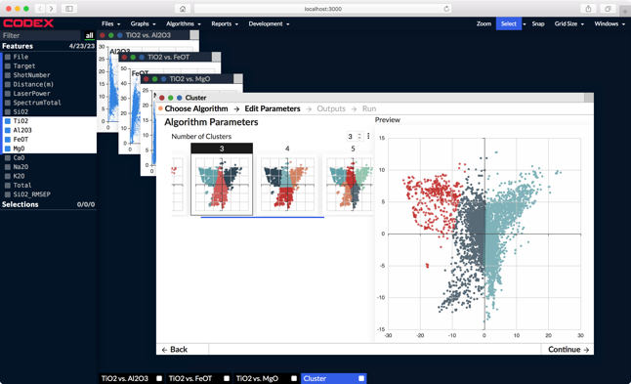

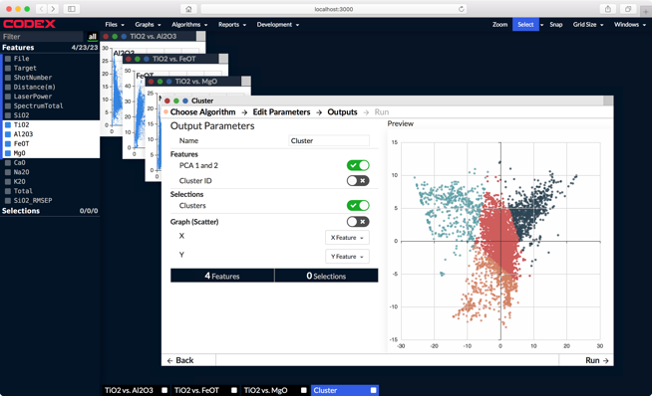 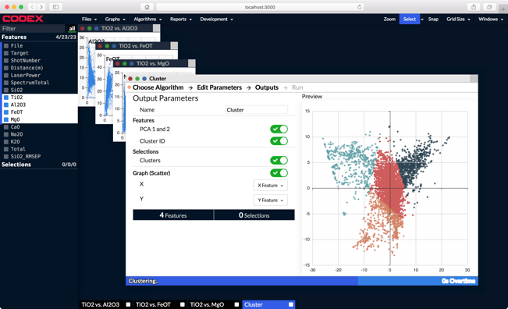

6. Color original scatter plots by the new clusters. Tile windows.

